* Accounts:
  + Get: http://localhost:8080/rest/accounts

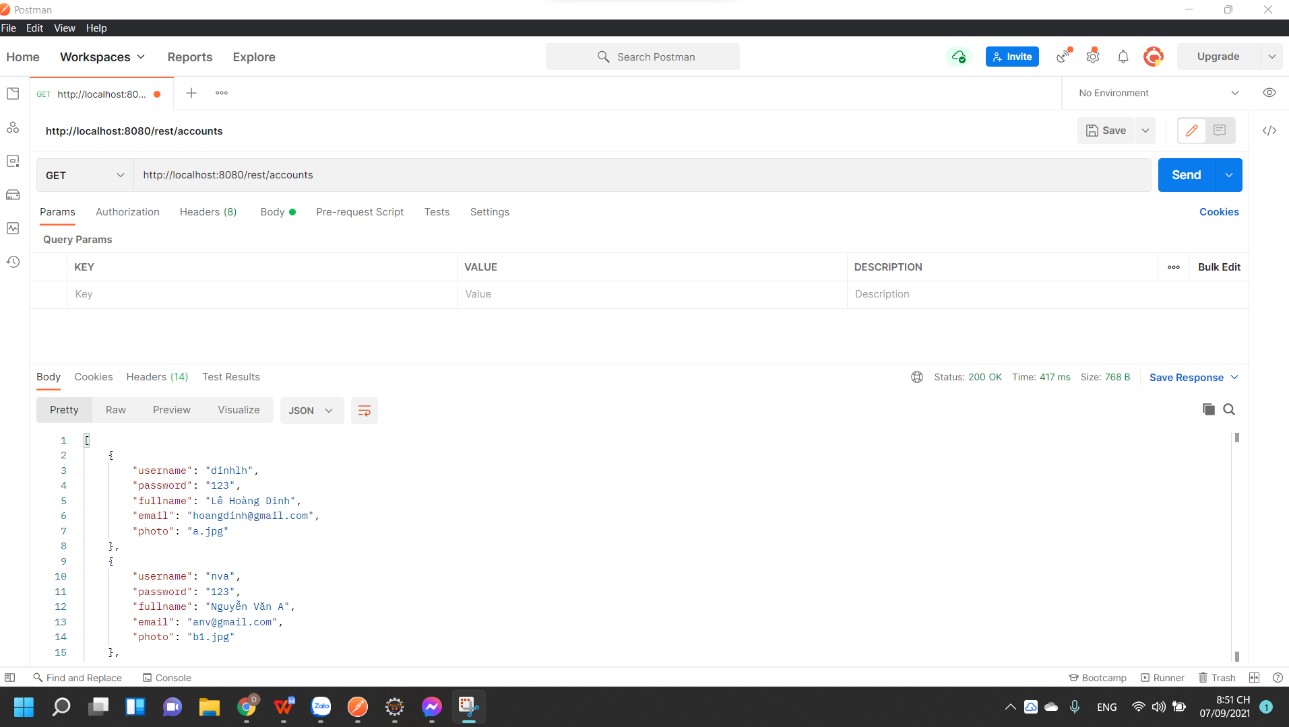

* + Post dữ liệu: <http://localhost:8080/rest/accounts>

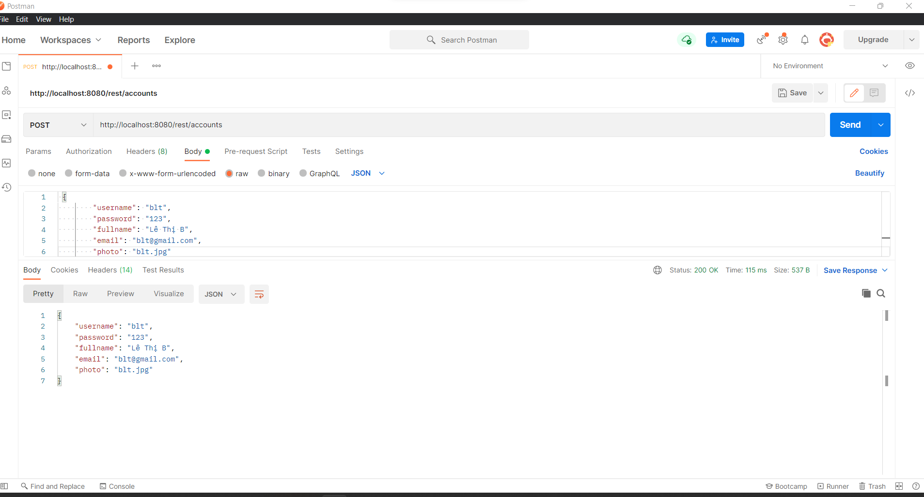

* + Put dữ liệu: http://localhost:8080/rest/accounts/dinhlh

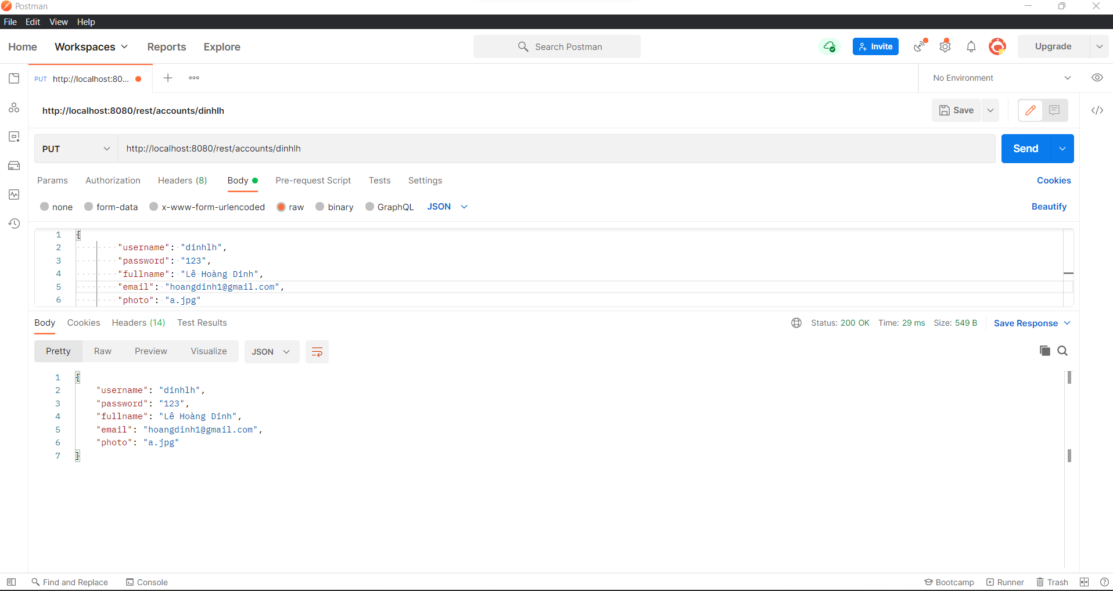

* + Delete dữ liệu: http://localhost:8080/rest/accounts/blt

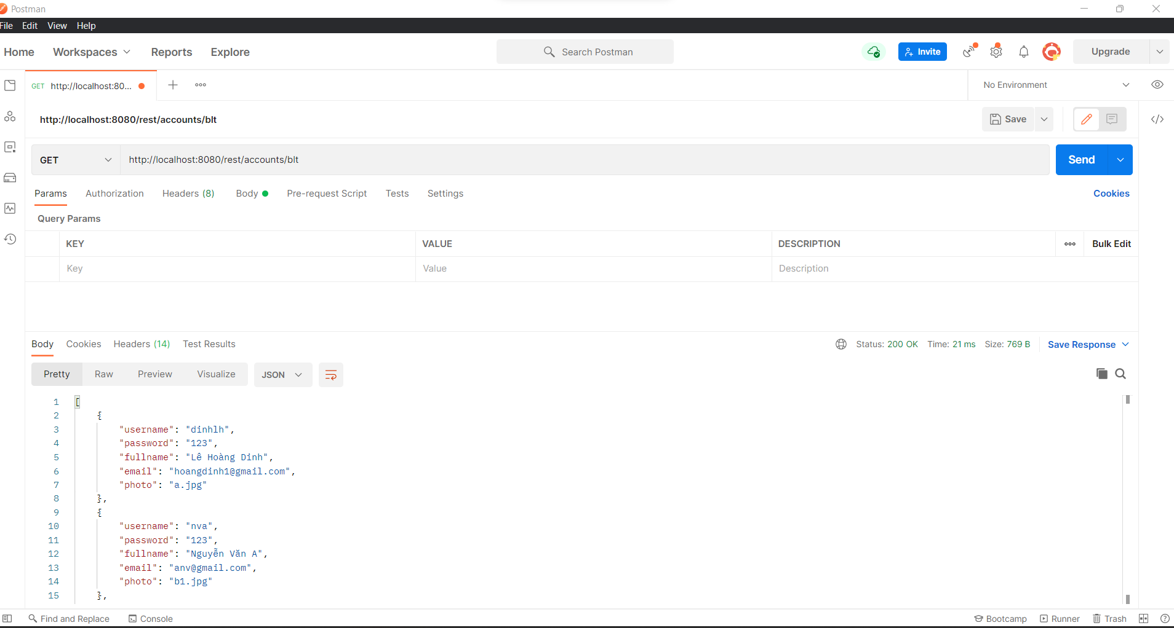

* Product:
  + Get dữ liệu: <http://localhost:8080/rest/products>

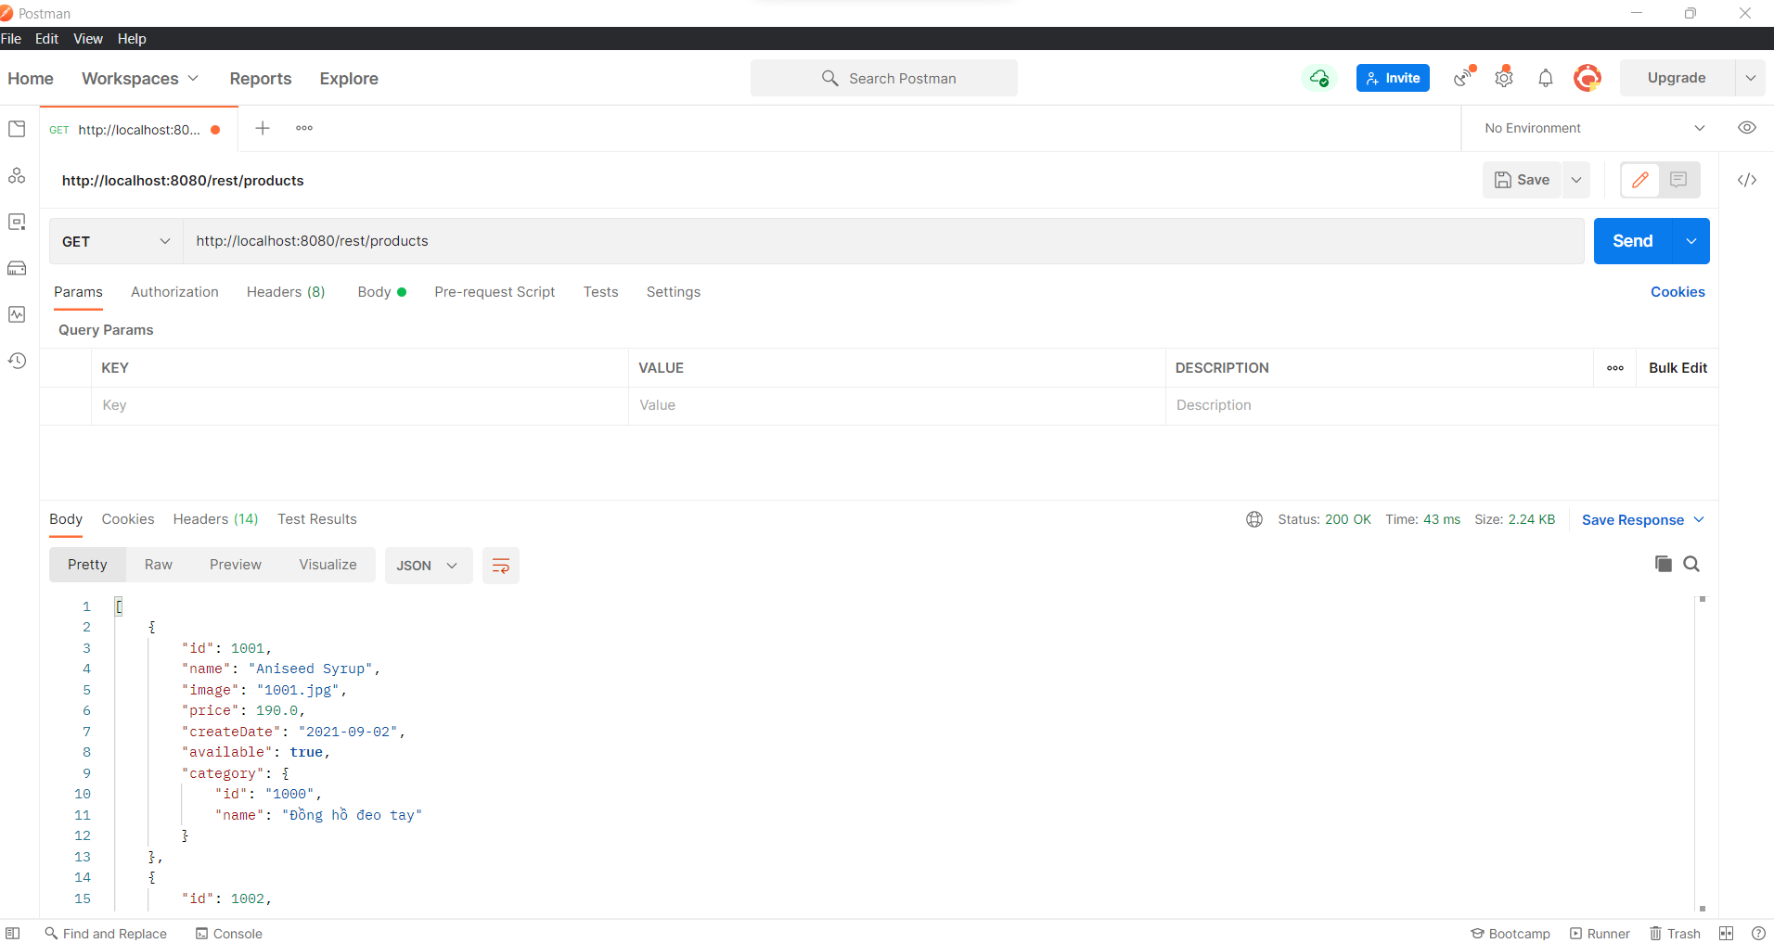

* + Post dữ liệu: <http://localhost:8080/rest/products>

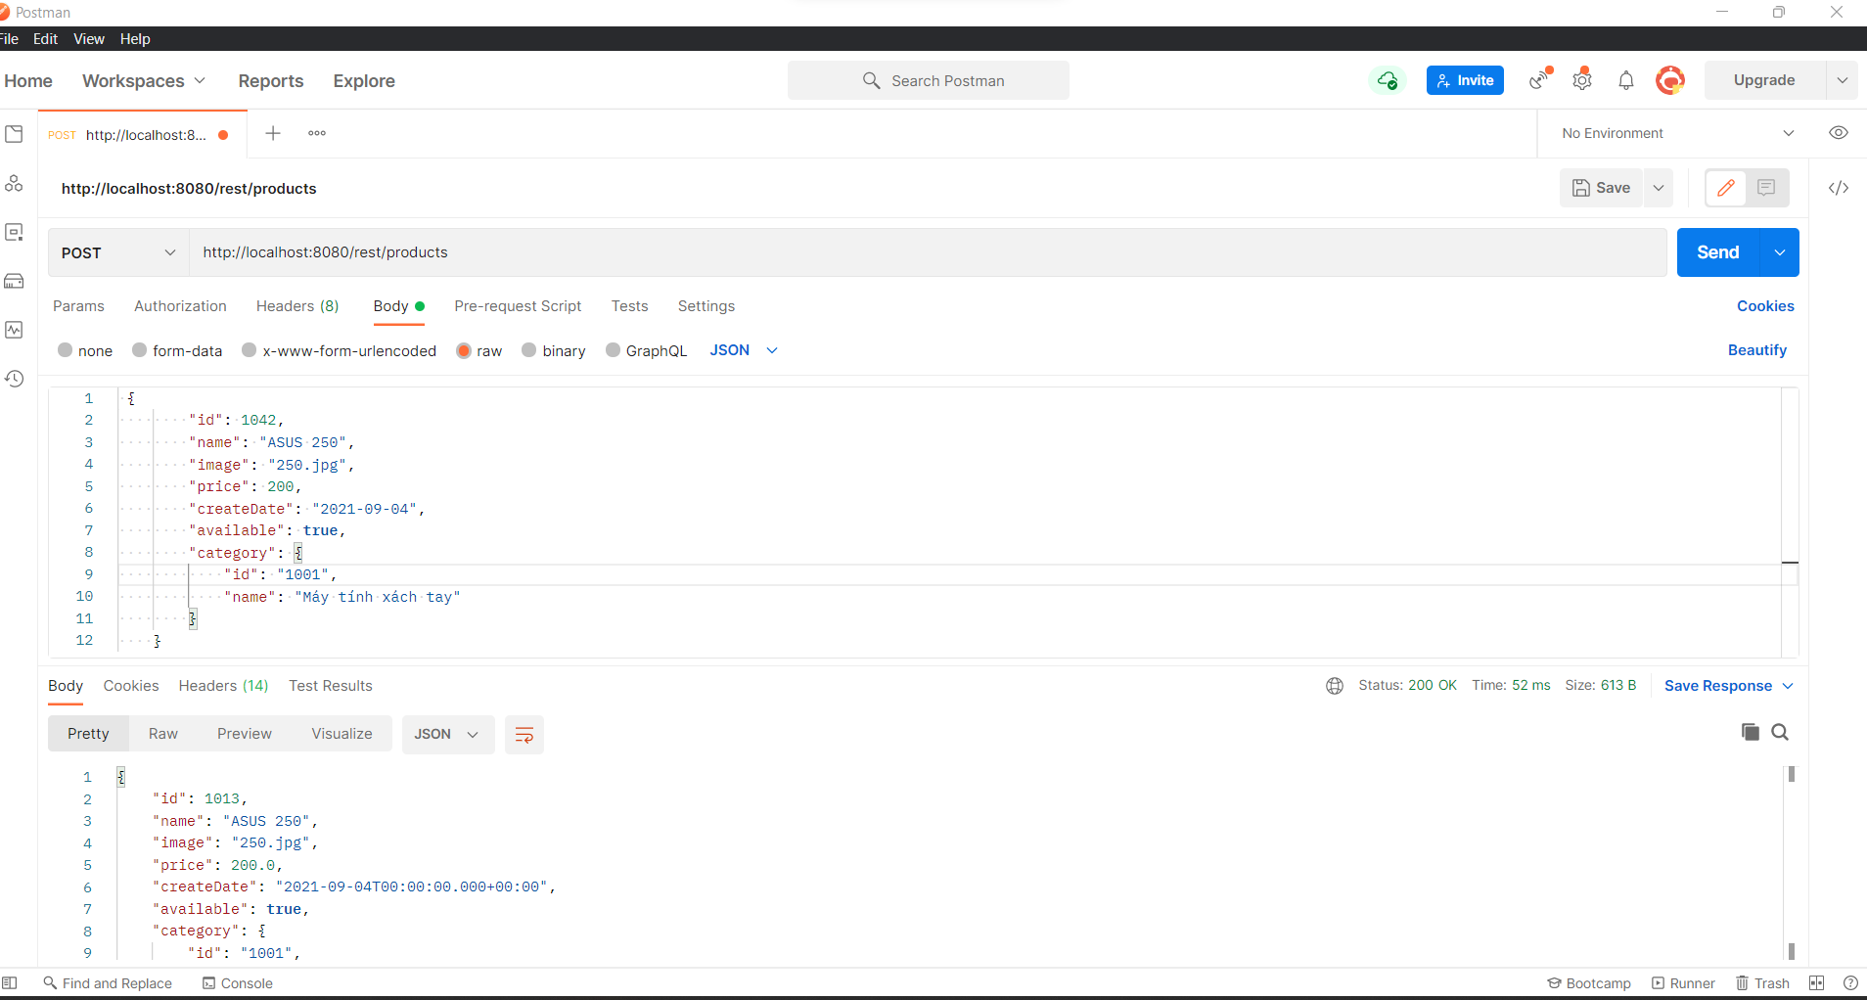

* + Put dữ liệu: http://localhost:8080/rest/products/1042

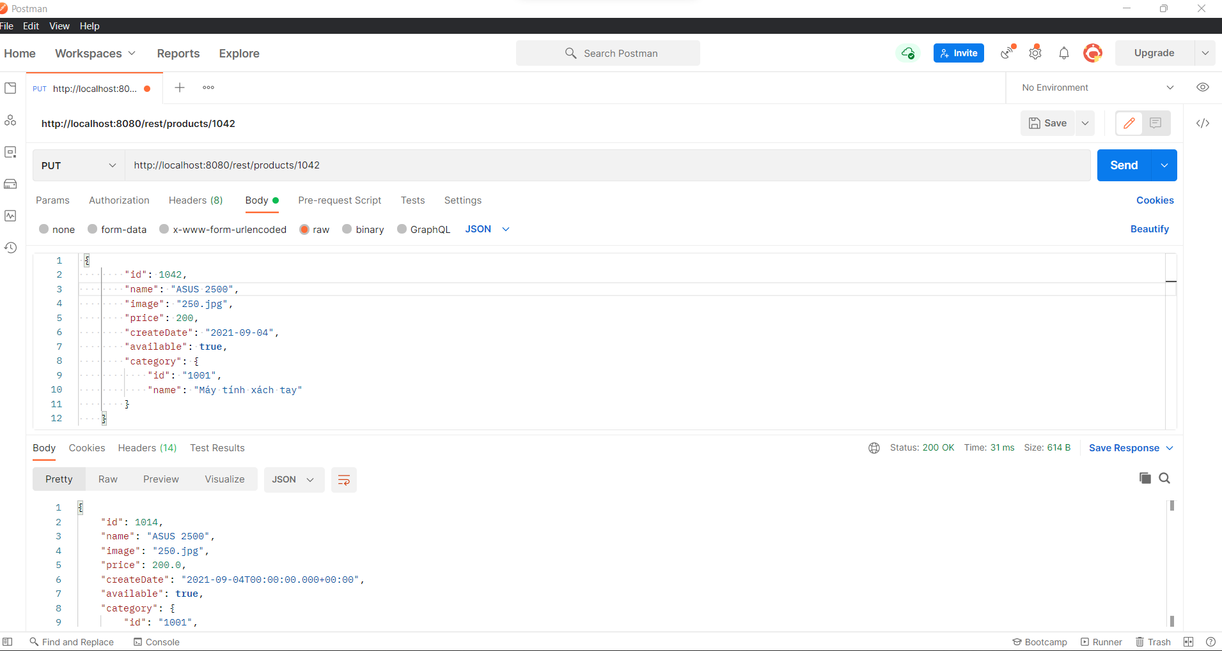

* + Delete dữ liệu: http://localhost:8080/rest/products/1042

